Hay Town Council

Clerk: Mr Nicholas Burdekin
Hay Town Council
Council Offices
Hay-on-Wye
HR3 5BX

01497 820296
townclerk@haytowncouncil.gov.uk
www.haytowncouncil.gov.uk

-
#
#####
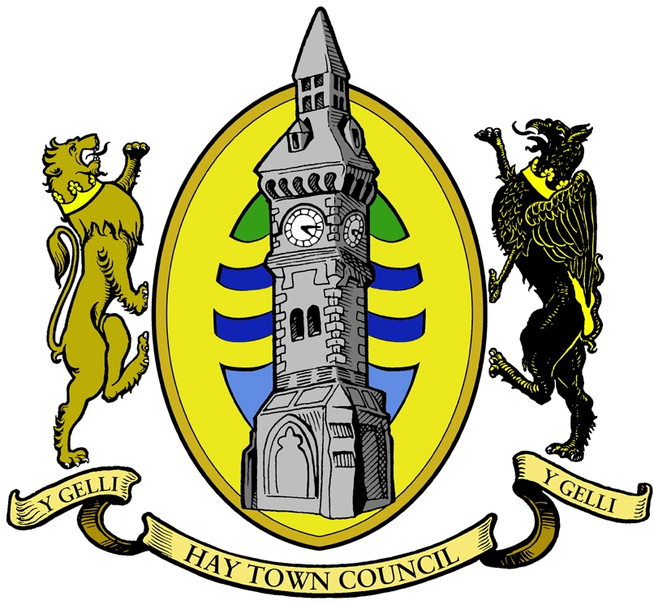

Mayor – Cllr S Morris

A Special Meeting of Hay Town Council will take place on Monday 28th June 2021 at 6.00pm via the Zoom platform

Please note, under the new Local Government and Elections (Wales) Act 2021, Councils are required to provide access to remote meetings for members of the public and the press. If you would like to access the meeting remotely, please see details at the bottom of the agenda on how to join via the Zoom platform

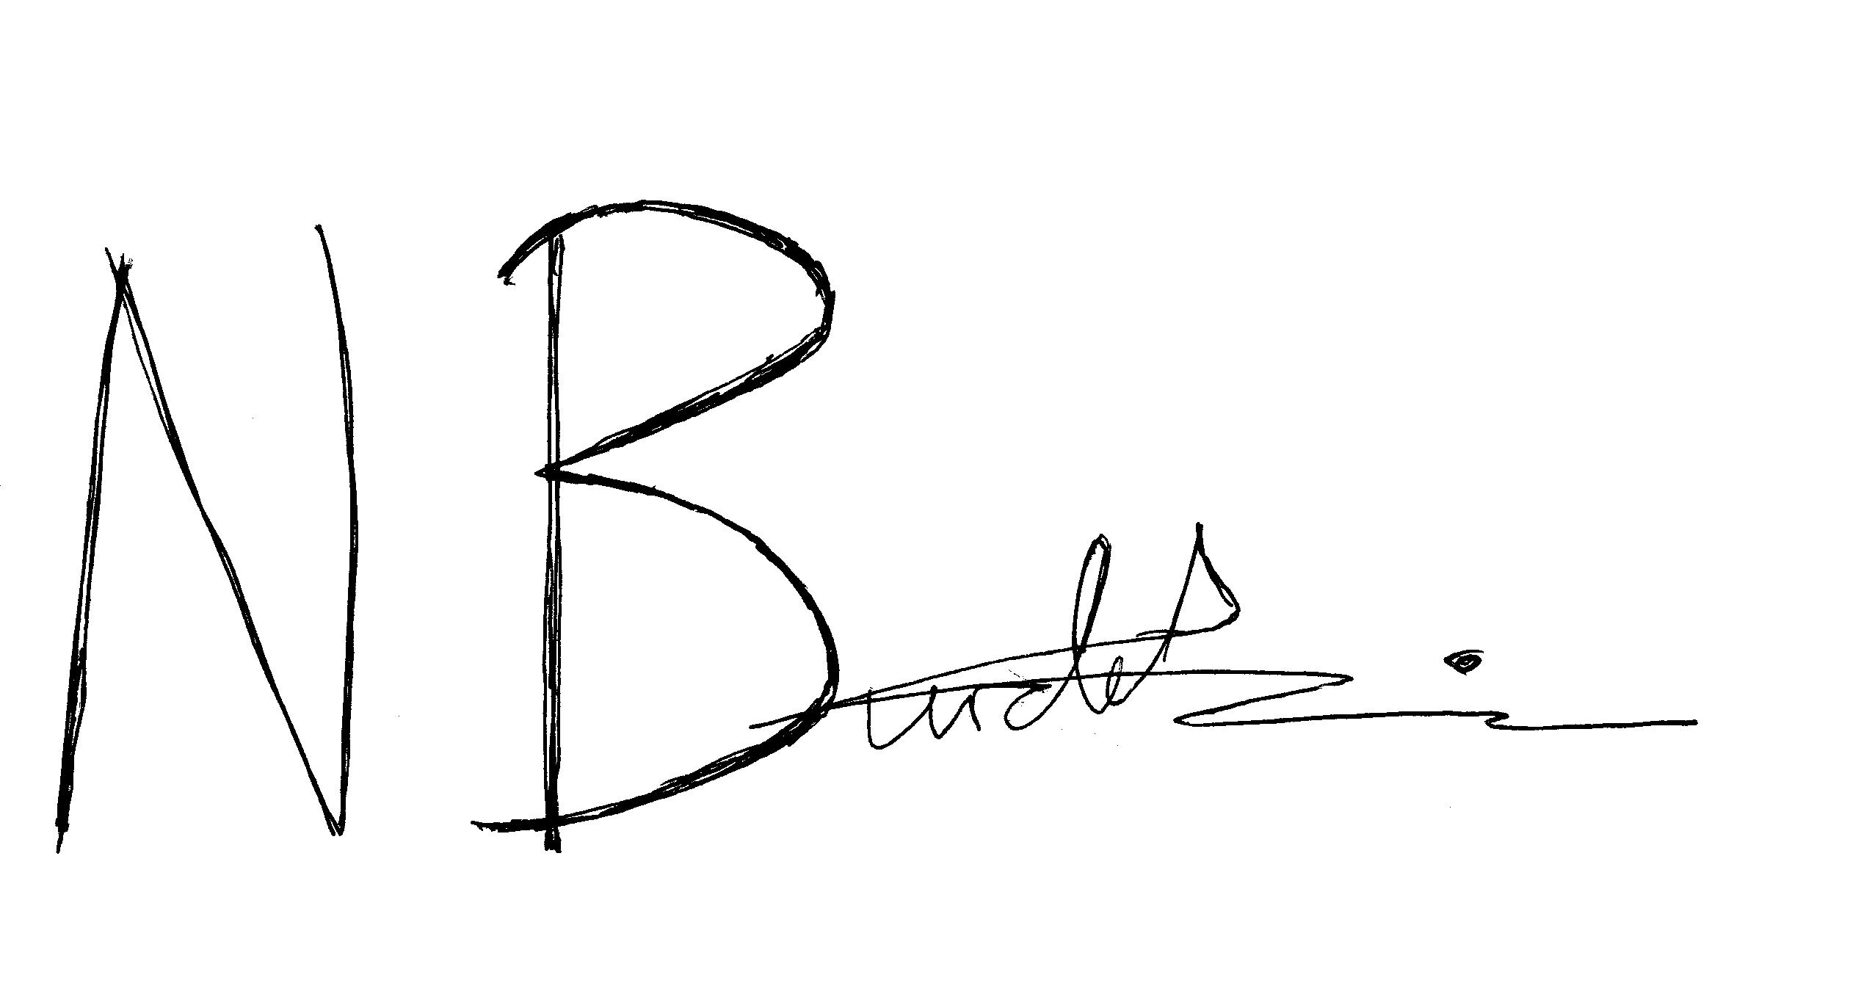

Nick Burdekin

Clerk to the Council

AGENDA

- Apologies for absence

- Declarations of Interest & Code of Conduct

- Certify Accounts for year ending 31 March 2021

- Date and time of next meeting Monday 5th July 2021

General Data Protection Regulations (GDPR) 2018

If you would like to attend the meeting virtually, please contact Hay Town Clerk at least one working day prior to the meeting on: townclerk@haytowncouncil.gov.uk or by calling 07714 224 554.

Please note, any e-mail addresses given by the press or members of the public for the purposes of joining the meeting remotely will be deleted from all Hay Town Council’s records directly after the meeting has occurred in order to fulfil Hay Town Council’s duty under the GDPR Regulations (2018).

General Data Protection Regulations (GDPR) 2018

If you would like to attend the meeting virtually, please contact Hay Town Clerk at least one working day prior to the meeting on: townclerk@haytowncouncil.gov.uk or by calling 07714 224 554.

Please note, any e-mail addresses given by the press or members of the public for the purposes of joining the meeting remotely will be deleted from all Hay Town Council’s records directly after the meeting has occurred in order to fulfil Hay Town Council’s duty under the GDPR Regulations (2018).

